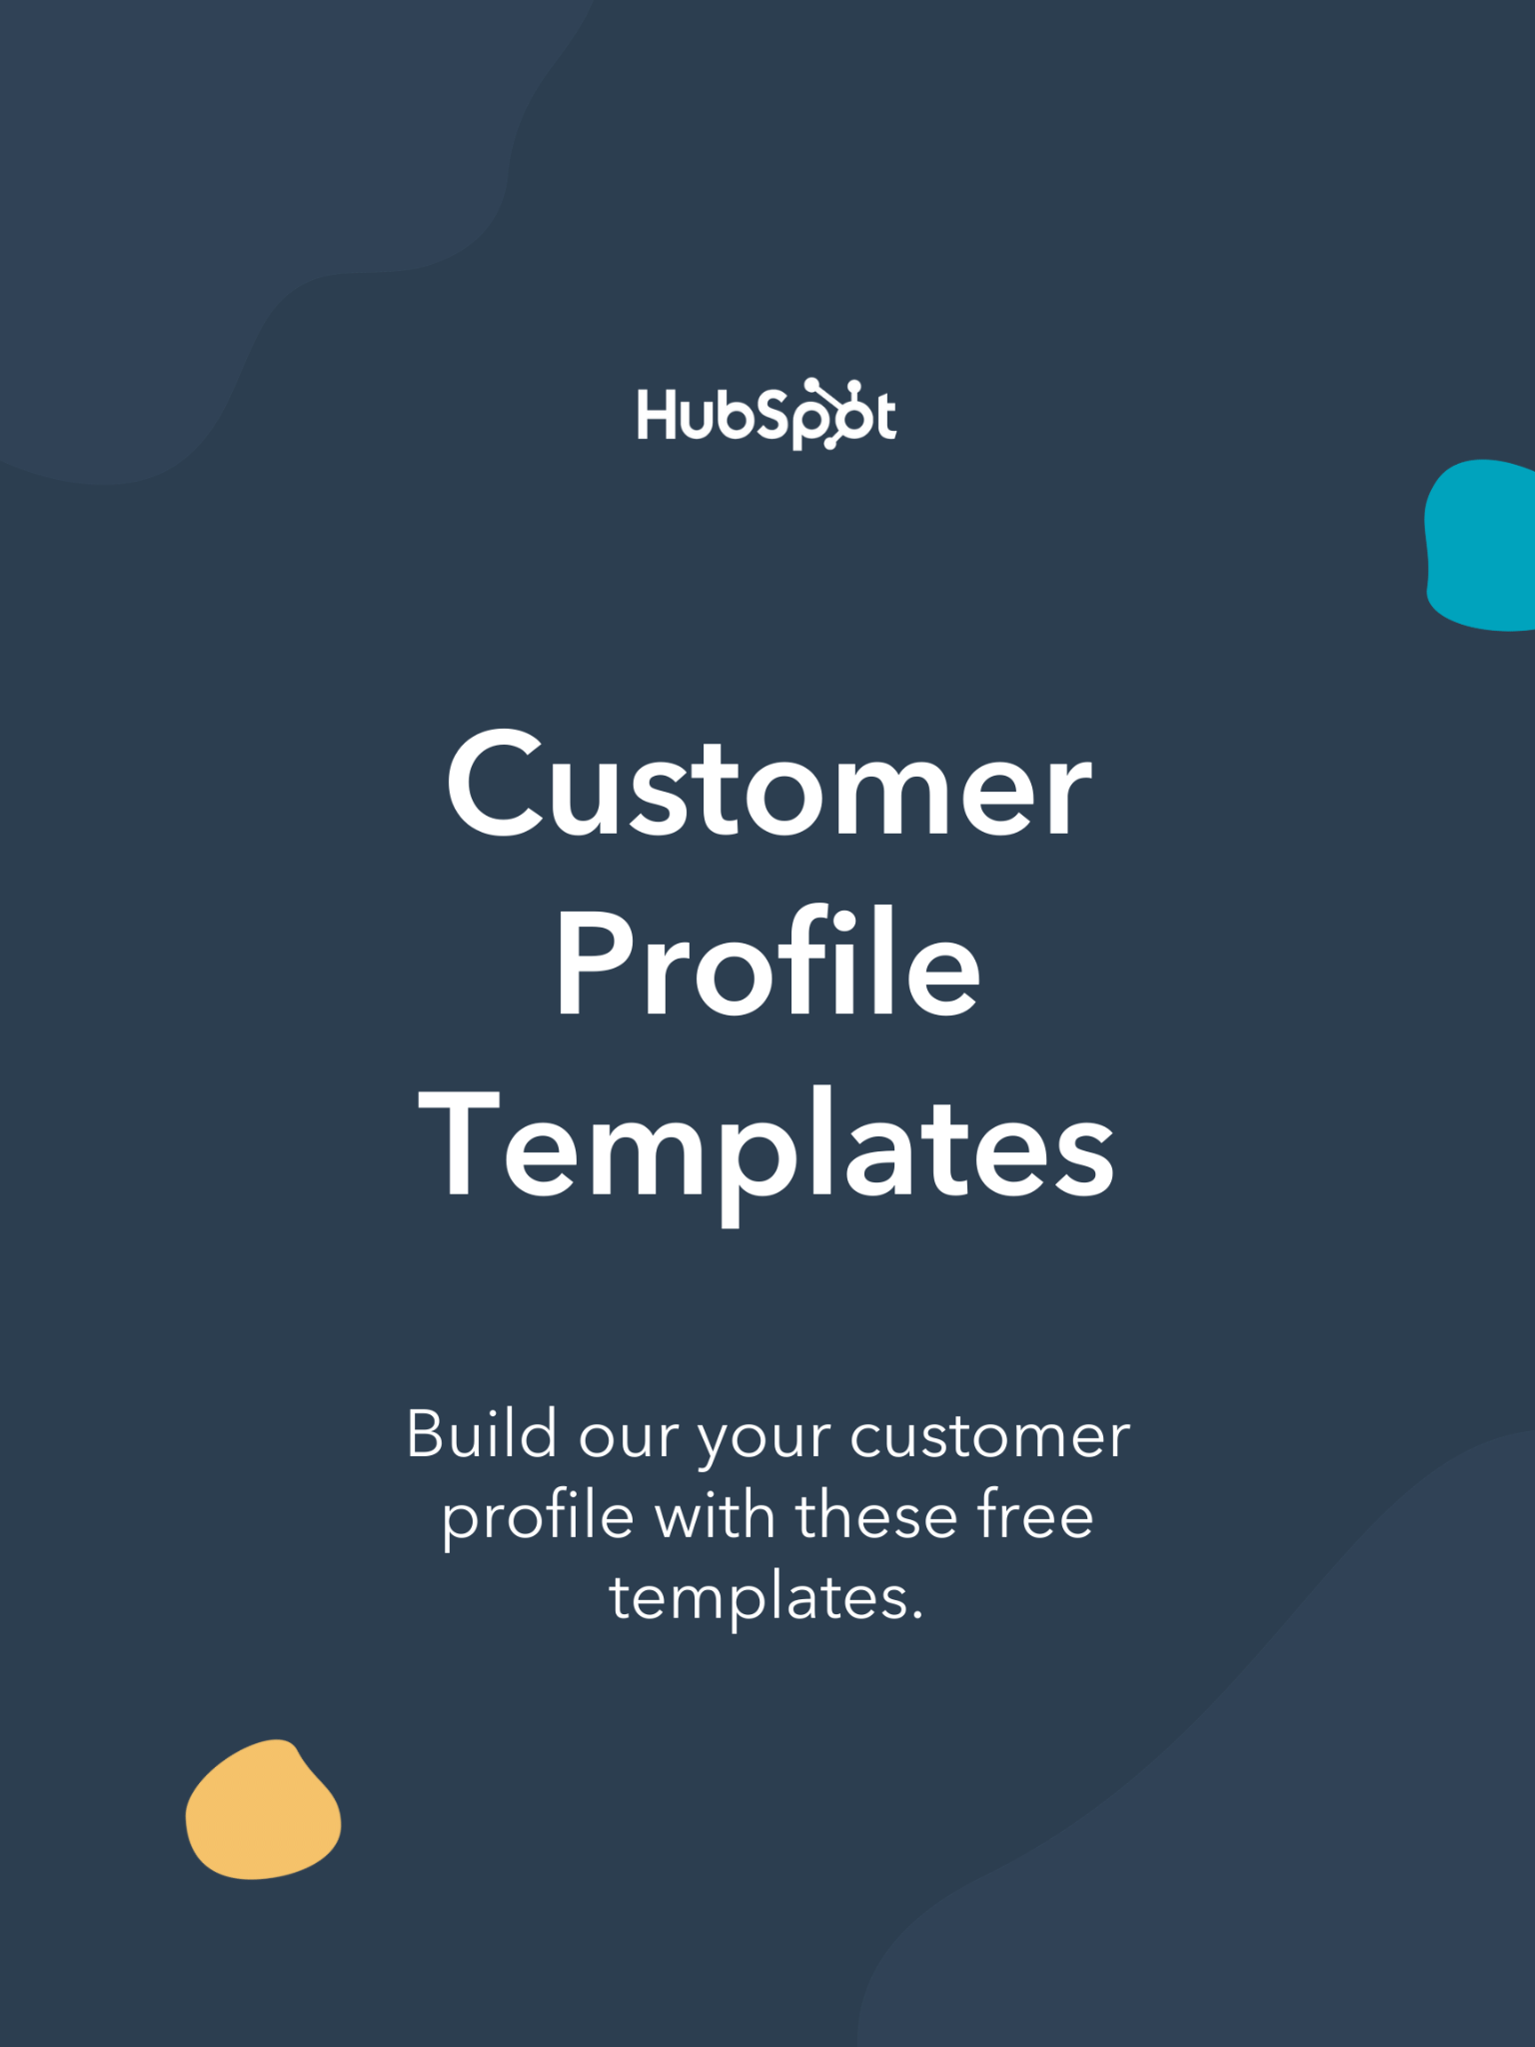

|  |
| --- |
| **Hi There.**  Thanks for Downloading This Resource.    You Can Edit Your Own Version in One of Two Ways:   1. Use this current version here on Google Docs. 2. Go to “File” > “Download As” > “Microsoft Word” to Download as a Word Document. |
| ↓↓↓  How to Use These Templates  This document contains two template prompts for a customer profile – one short and one long. Words in [brackets] or *italicized* are meant to be replaced with information about your customers.  Once complete, you’ll have an in-depth profile for your intended customer to share with marketers, sales reps, account managers, and/or support reps. Don’t forget to make copies of these templates so you can create a profile for as many customers as your organization needs. |

|  |  |
| --- | --- |
| Get a Customer Service Tool  for Your Scaling Business  Learn more about HubSpot’s Service  Hub Software to help you support your customers. |  |
| [**Get Started Free**](https://www.hubspot.com/products/service?utm_source=offers&utm_medium=offers&utm_campaign=seondary-conversion_customer-profile_template) | |

(Keep scrolling to templates)

↓↓↓

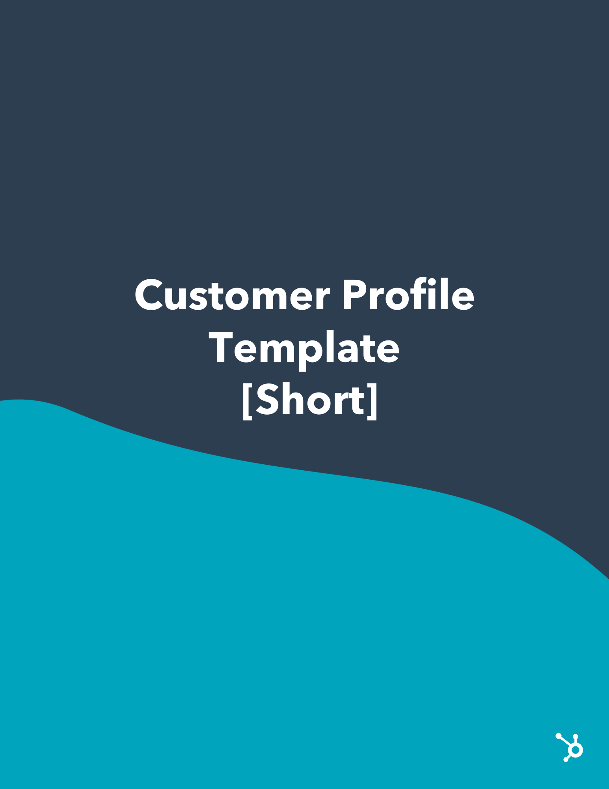

|  |  |  |
| --- | --- | --- |
| Customer Profile | **Products/Services Used**  *Customer uses [product] to do [task].*  *Customer uses [product] to do [task].*  *Customer uses [product] to do [task].* | |
| **Demographics**   * Career: Enter Career * Industry: Enter Industry * Location: Enter Location * Gender: Enter Gender   **Customer Story**  *Summarize the customer’s story in a couple of sentences. Speak to the traits that match up with them being a customer. You can also speak to whether or not they chose you over a competitor.* | **Customer Benefits**  *Customer Benefit*  *Customer Benefit*  *Customer Benefit*  *Customer Benefit* | Customer Pain Points  *Customer Pain Point*  *Customer Pain Point*  *Customer Pain Point*  *Customer Pain Point* |
| Customer Communication Talking Points  *Talking Point*  *Talking Point*  *Talking Point*  *Talking Point* | Customer Retention Tactics  *Retention Tactic*  *Retention Tactic*  *Retention Tactic*  *Retention Tactic* |

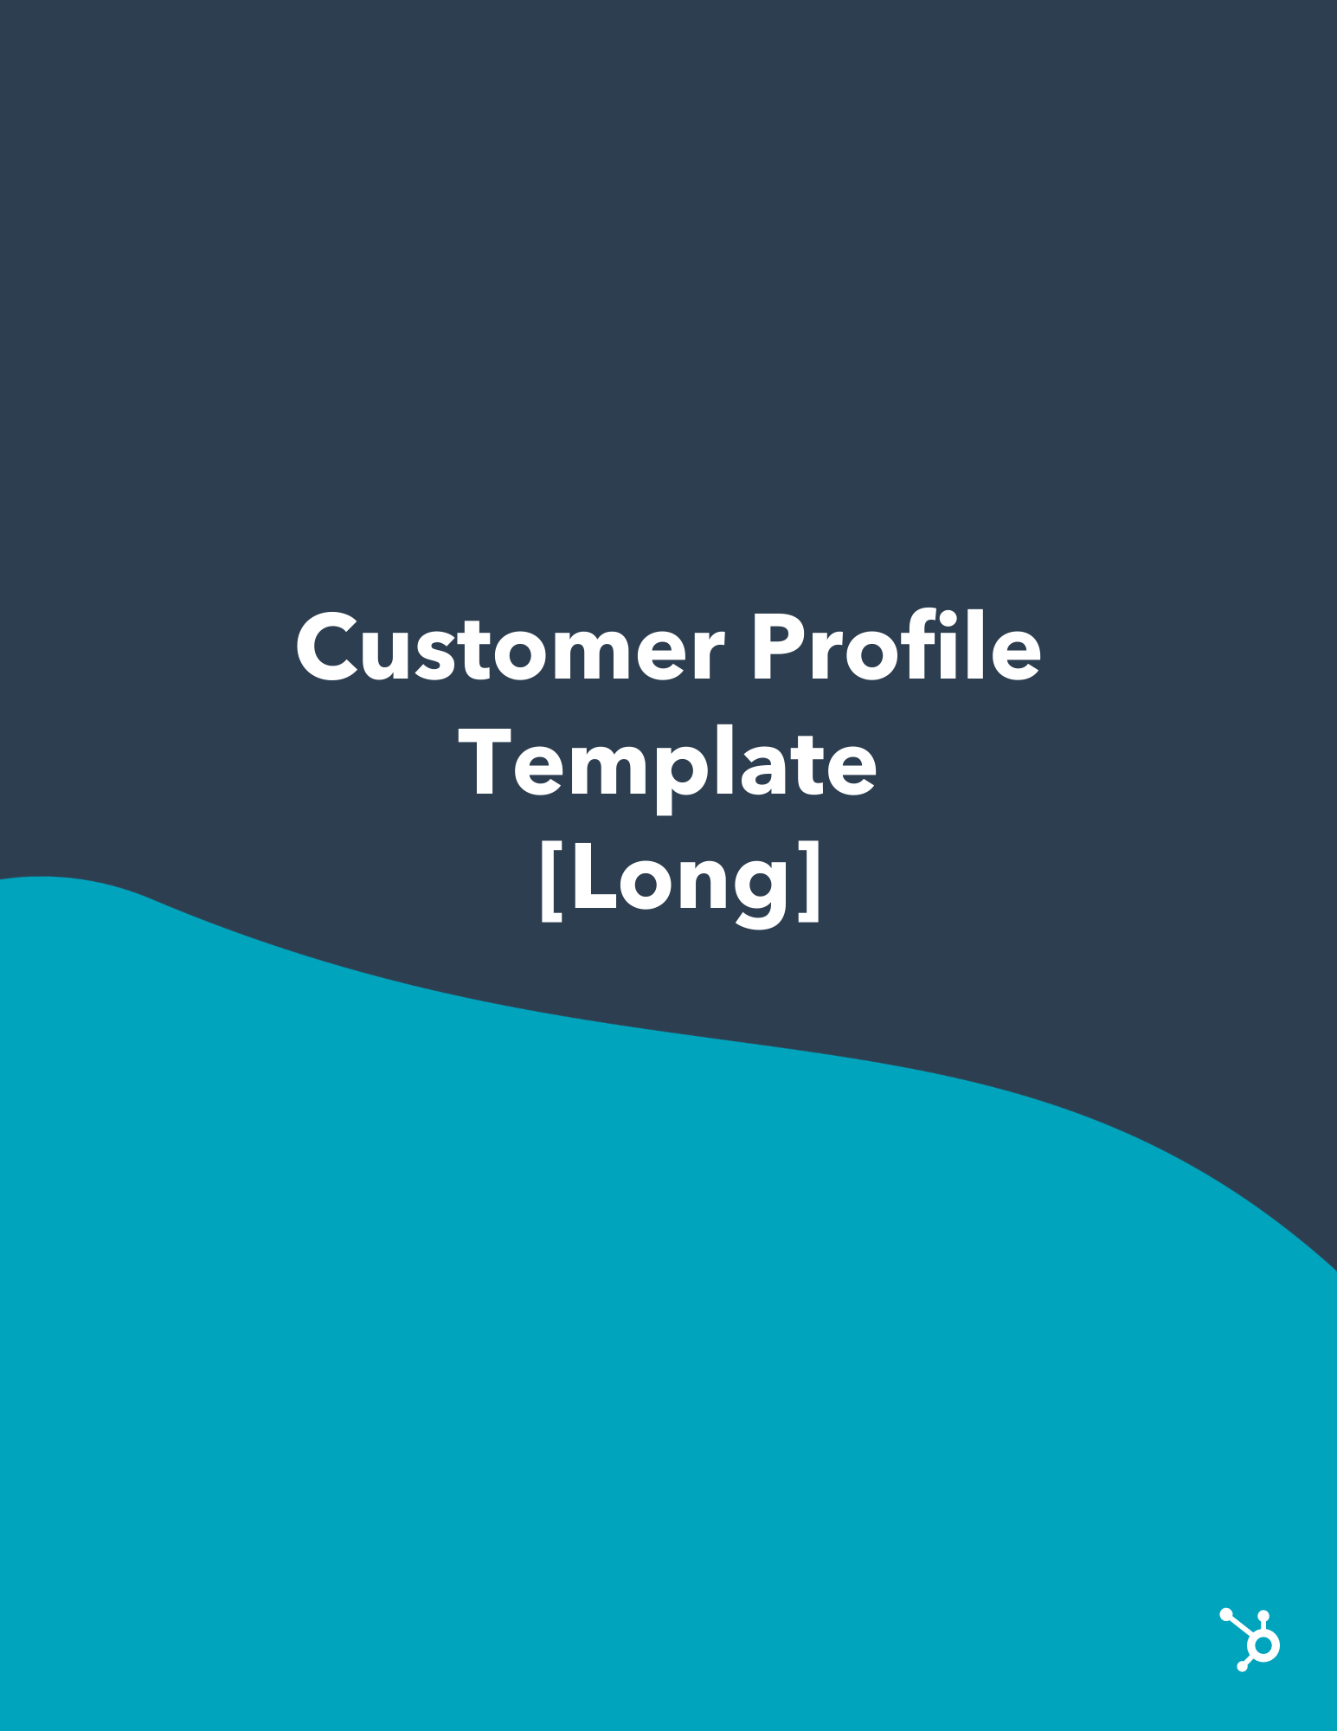

|  |  |
| --- | --- |
|  | **Customer Profile**  ***I****nclude a brief, insightful summary about the customer you are profiling in this introductory section.* |

|  |  |
| --- | --- |
| **External Attributes (Step 1)** | |
| Customer Industry | *State the customer’s industry.* |
| Customer Vertical | *State the customer’s vertical.* |
| Customer Profit/Revenue | *State the customer’s (projected) revenue and profit.* |
| Customer Employee Size | *State the number of employees at the customer’s company.* |
| Customer Location | *State the location of the customer(‘s company).* |

|  |  |
| --- | --- |
| **Contextual Details (Step 2)** | |
| Team Size | *State the customer’s team size.* |
| Team Challenges | *List out the customer’s team challenges at their company.* |
| Technologies Using | *List out the technologies the customer uses to do their job.* |
| Short-Term Goals | *List out the customer’s short-term (three-month) team goals.* |
| Long-Term Goals | *List out the customer’s long-term (one-year) team goals.* |
| Problem Assessment Process | *Explain the customer’s process for assessing problems.* |
| Impact of Main Challenges | *Explain the impact the challenges have on your customer.* |
| Challenge Response Tactics | *Explain how the team currently faces its challenges.* |

|  |  |
| --- | --- |
| **Personas (Step 3)** | |
| Customer Job Title | *State the customer’s job title.* |
| Customer Age (Range) | *State the customer’s age or age range.* |
| Customer Education Level | *State the customer’s education level.* |
| Customer Income | *State the customer’s income.* |
| Customer’s Key Responsibilities | *List out the customer’s key responsibilities.* |
| Product Use Overview | *Explain how the customer will use your product.* |
| Marketing Channels | *Provide an overview of the marketing channels that are more effective for reaching this customer.* |
| Decision Making Process | *Provide an overview of your customer’s decision making process.* |

|  |  |
| --- | --- |
| **How Does Your Product/Service Help? (Step 4)** | |
| Perceived Product Value | *Explain the value that your business provides your customer.* |
| Products Utilized | *List out which of your product(s)/service(s) your customer uses.* |
| Solutions Provided | *Explain how your product(s)/service(s) solve customer pain points.* |
| Product Pain Points | *List out the pain points your customer may experience while using your product.* |
| Perceived Competitive Advantages | *List out the features that differentiate you from competitors.* |